Wearl Ian G. Baguio Student No.:202101723 CPEN65

1. Three properties of tree is as follows: (not the kinds of trees)

* Cyclic, connected, and an undirected graph.
* It does have root, branch, and leaves.
* A tree is a forest, but a forest will never be a tree for it is not connected.

2. Yes, a tree is a forest.

3. Root

4. One

5. Yes

6. The children of node 16 is: 13, 6, 60

7. The parent of node 1 is 7

8. None

9. The ancestors of 9 from its parent to the root is: 4, 12, 7, and 22

10. The descendants of 16 are: 23, 13, 6, 60, and 12

11. The leaves are: 23, 6, 21, 20, 9, and 1

12. The non-leaves are: 13, 60, 16, 22, 7, 12, and 4

13. The depth is 3

14. The of the tree is 3

15. The height of the tree is 4

16. The weight of the tree is 6

17. No it isn’t, because a binary tree must only have 2 degrees, but the given tree has 3

18. No

19. No

20. No

21. Yes

22.

23. $\log_{n}m$

24. $\frac{k^{h}-1}{n-1}$

25. $n^{h}-1$

Graphs Task(s)

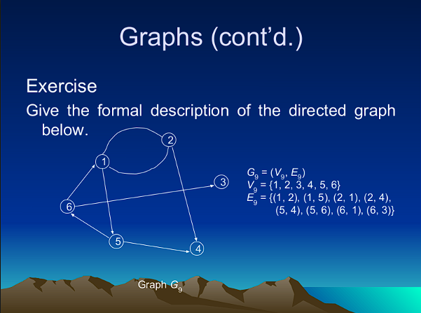

Indegree of:

1 is 2

2 is 1

3 is 1

4 is 2

5 is 1

6 is 1

Outdegree of:

1 is 2

2 is 2

3 is 0

4 is 0

5 is 2

6 is 2

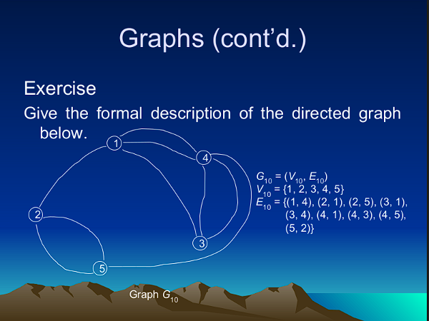

Indegree of:

1 is 3

2 is 1

3 is 1

4 is 2

5 is 2

Outdegree of:

1 is 1

2 is 2

3 is 2

4 is 3

5 is 1

(See Next Page)

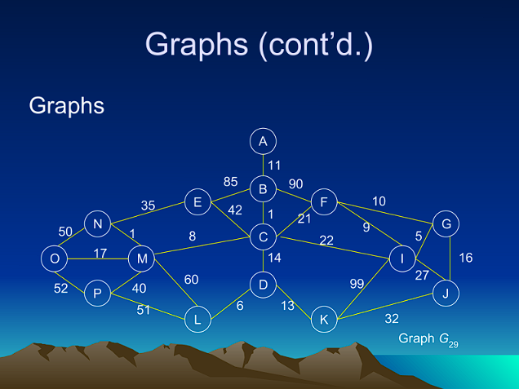

Kruskal’s Algorithm:

Weight(B, C) = 1

Weight(N, M) = 1

Weight(G, I) = 5

Weight(D, L) = 6

Weight(C, M) = 8

Weight(F, I) = 9

~~Weight(F, G) = 10~~

Weight(A, B) = 11

Weight(D, K) = 13

Weight(C, D) = 14

Weight(G, J) = 16

Weight(M, O) = 17

Weight(C, F) = 21

~~Weight(C, I) = 22~~

~~Weight(I, J) = 27~~

~~Weight(J, K) = 32~~

Weight(E, N) = 35

Weight(M, P) = 40

~~Weight(C, E) = 42~~

~~Weight(N, O) = 50~~

~~Weight(L, P) = 51~~

~~Weight(O, P) = 52~~

~~Weight(L, M) = 60~~

~~Weight(B, E) = 85~~

~~Weight(B, F) = 90~~

~~Weight(I, K) = 99~~

Prim’s Algorithm:

Weight(A, B) = 11

Weight(B, C) = 1

Weight(C, M) = 8

Weight(N, M) = 1

Weight(C, D) = 14

Weight(D, L) = 6

Weight(D, K) = 13

Weight(M, O) = 17

Weight(C, F) = 21

Weight(F, I) = 9

Weight(G, I) = 5

Weight(G, J) = 16

Weight(M, P) = 40

Graph of Kruskal’s Algorithm

~~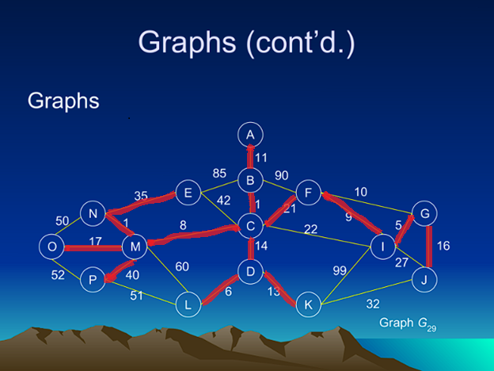~~

Graph of Prim’s Algorithm

